CMSC204

Kartchner

Kisa Zormelo

V(StateGraph) = {Oregon, Alaska, Texas, Hawaii, Vermont, NewYork, California}

E(StateGraph) = {(Alaska, Oregon), (Hawaii, Alaska), (Hawaii, Texas), (Texas, Hawaii), (Hawaii, California), (Hawaii, New York), (Texas, Vermont), (Vermont, California), (Vermont, Alaska)}

1. Draw the StateGraph

Oregon



1. Describe the graph pictured above, using the formal graph notation.

V(StateGraph) = vertices that are connected by the edges (Oregon, Alaska, Texas, Hawaii, NewYork, Vermont, California)

E(StateGraph) = edges of the graph, linked between two vertices

Example: Hawaii- Texas, Texas-Vermont

1. a. Is there a path from Oregon to any other state in the graph? No
2. Is there a path from Hawaii to every other state in the graph? Yes
3. From which state(s) in the graph is there a path to Hawaii?

From Texas

1. a. Show the adjacency matrix that would describe the edges in the graph. Store the vertices in alphabetical order

|  |  |  |  |  |  |  |  |
| --- | --- | --- | --- | --- | --- | --- | --- |
| Alaska | 0 | 0 | 0 | 0 | 1 | 0 | 0 |
| California | 0 | 0 | 0 | 0 | 0 | 0 | 0 |
| Hawaii | 1 | 1 | 0 | 1 | 0 | 1 | 0 |
| New York | 0 | 0 | 0 | 0 | 0 | 0 | 0 |
| Oregon | 0 | 0 | 0 | 0 | 0 | 0 | 0 |
| Texas | 0 | 0 | 1 | 0 | 0 | 0 | 1 |
| Vermont | 1 | 1 | 0 | 0 | 0 | 0 | 0 |

b. Show the adjacency lists

that would describe the edges in the graph

|  |  |  |  |  |
| --- | --- | --- | --- | --- |
| Alaska | Oregon |  |  |  |
| California |  |  |  |  |
| Hawaii | Alaska | California | New York | Texas |
| New York |  |  |  |  |
| Oregon |  |  |  |  |
| Texas | Vermont | Hawaii |  |  |
| Vermont | Alaska | California |  |  |
|  |  |  |  |  |

4 a. Which of the following lists the graph nodes in depth first order beginning with E?

A) E, G, F, C, D, B, A

B) G, A, E, C, B, F, D

C) E, G, A, D, F, C, B

D) E, C, F, B, A, D, G

Option C.

4 b. Which of the following lists the graph nodes in breadth first order beginning at F?

A) F, C, D, A, B, E, G

B) F, D, C, A, B, C, G

C) F, C, D, B, G, A, E

D) a, b, and c are all breadth first traversals

Option A.

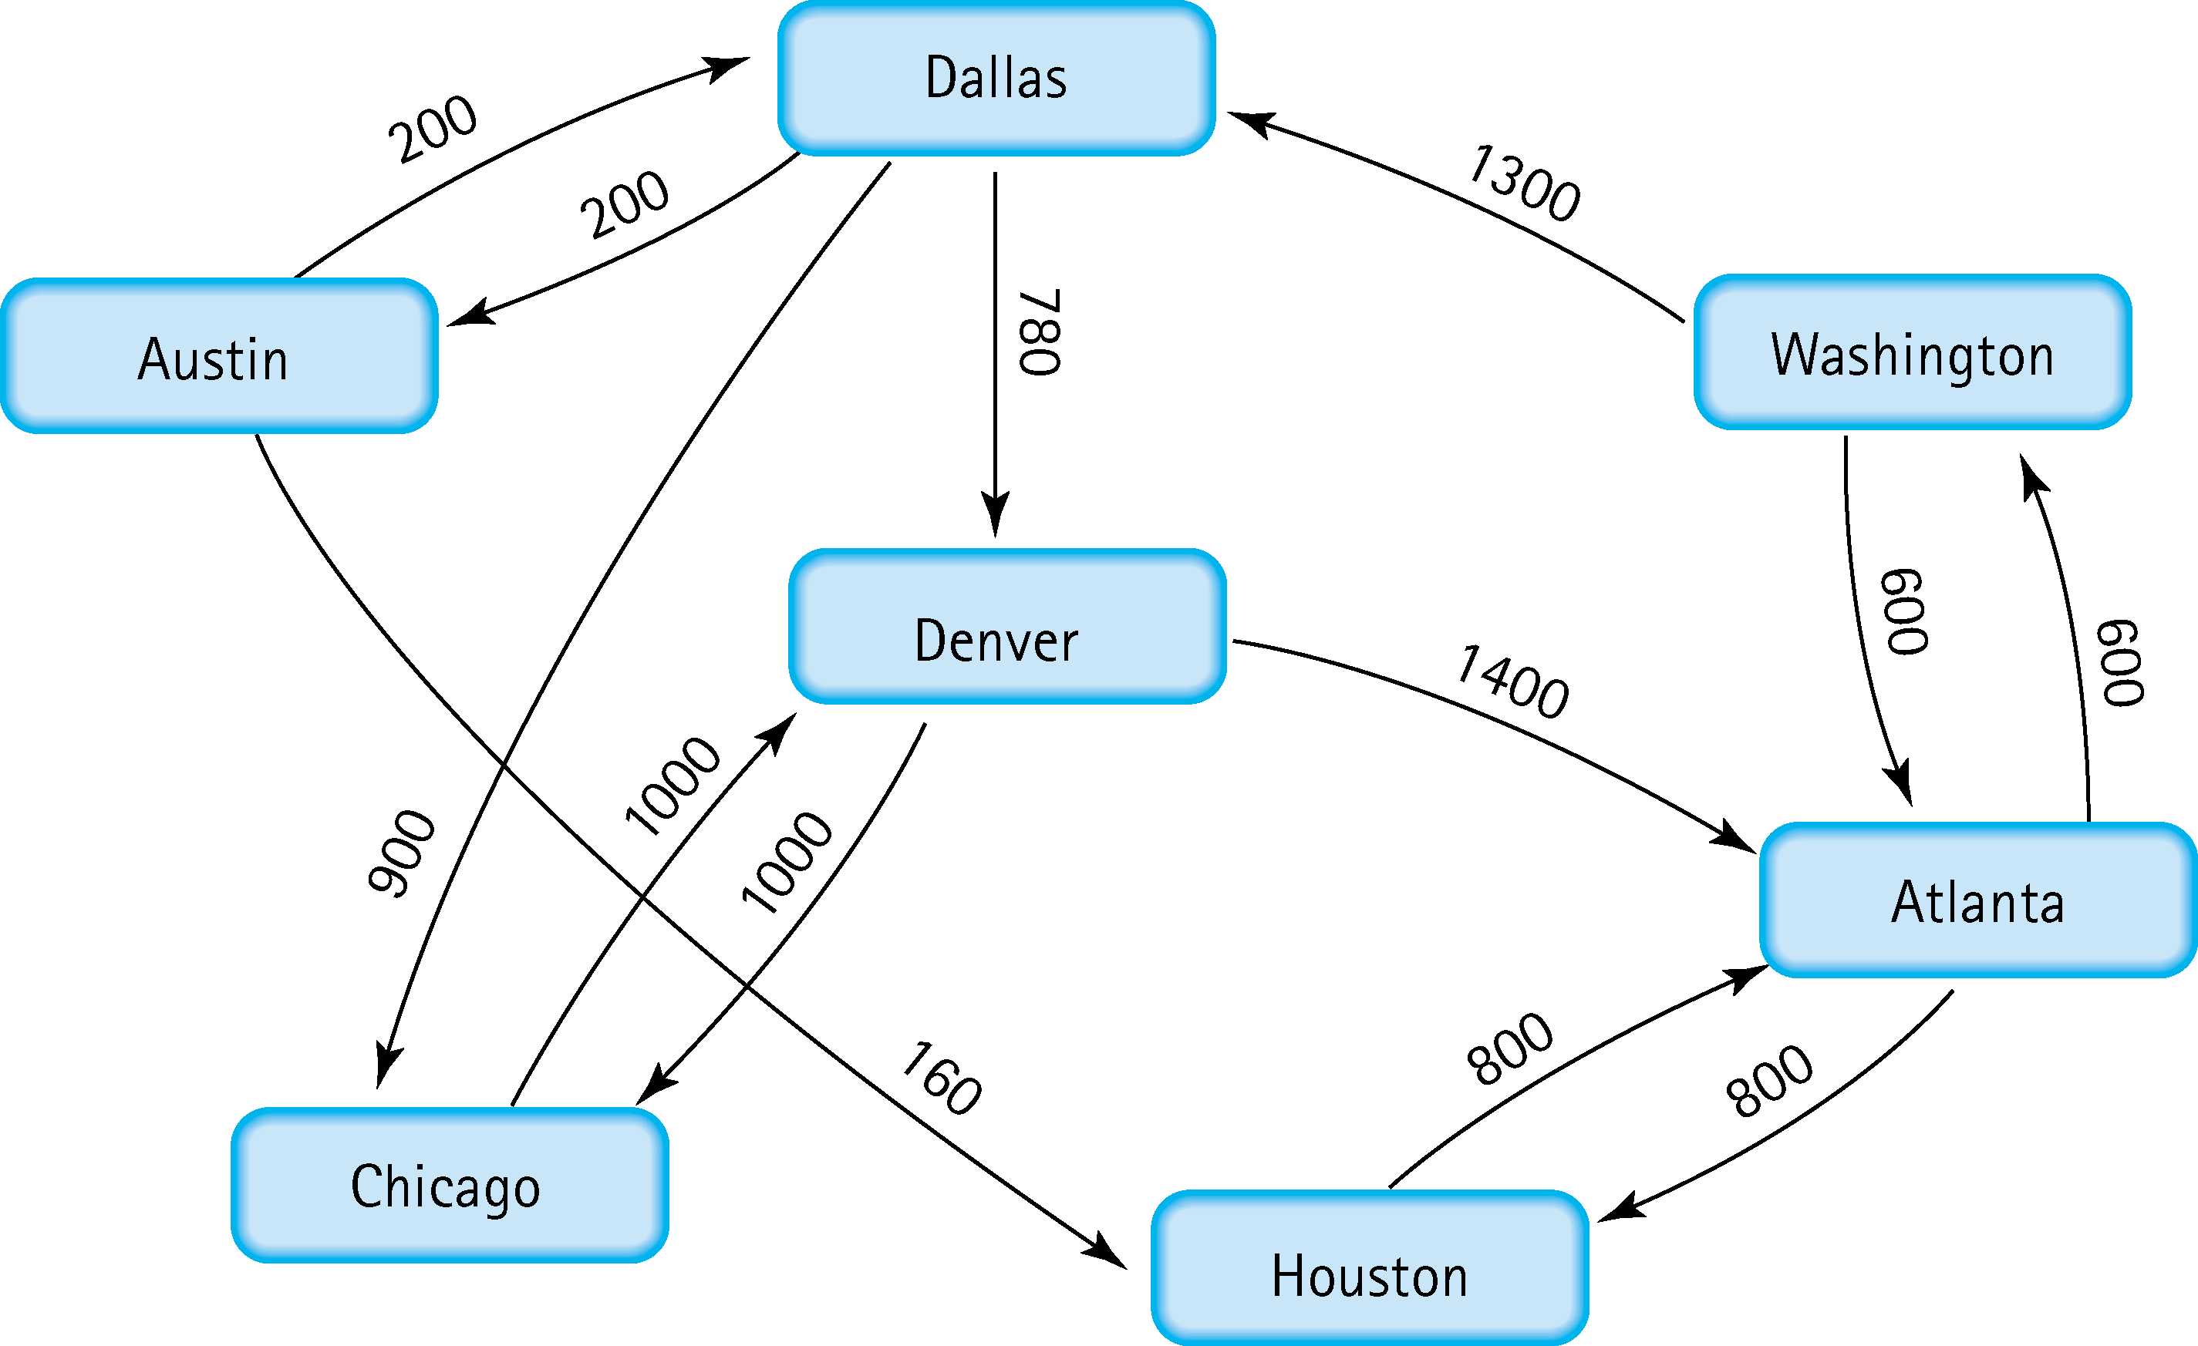

5. Find the shortest distance from Atlanta to every other city

Atlanta to Austin is 2100

Atlanta to Chicago is 2800

Atlanta to Dallas is 1900

Atlanta to Denver is 2680

Atlanta to Houston is 800

Atlanta to Washington is 600

6. Find the minimal spanning tree using Prim’s algorithm. Use 0 as the source vertex . Show the steps.

1. 0 to 2 < 0 to 1, 0 to 2
2. 2 to 5
3. 5 to 1
4. 5 to 4
5. 1 to 3

7. Find the minimal spanning tree using Kruskal’s algorithm.

Show the weights in order and the steps.

1. Least edge : 2 to 5
2. Nest smallest edge 5 to 1
3. 5 to 4 and 2 to 0
4. 1 to 3

8. Find the minimal spanning tree using the algorithm you prefer. Use

Minneapolis/St. Paul as the source vertex

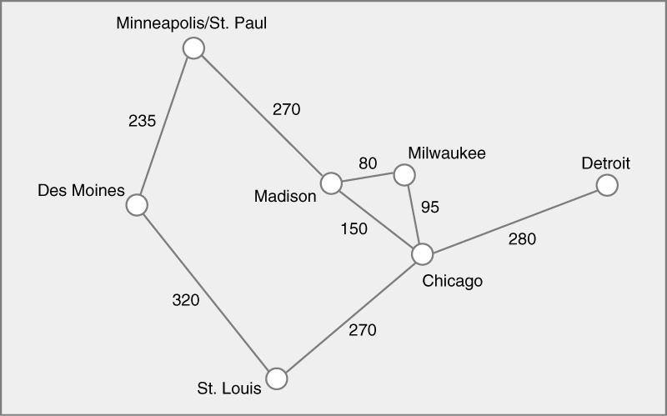

Using Krushal’s : {80, 95, 150, 235, 270, 280, 320}

{ 95, 150, 235, 270, 280, 320}

{150, 235, 270, 280, 320}

{235, 270, 280, 320}

{270, 280, 320}

{280, 320}

{320}

9. List the nodes of the graph in a breadth first topological ordering. Show the

steps using arrays predCount, topologicalOrder and a queue

|  |  |  |  |  |  |  |  |  |  |  |
| --- | --- | --- | --- | --- | --- | --- | --- | --- | --- | --- |
| predCount | 0 | 1 | 1 | 3 | 3 | 2 | 2 | 0 | 2 | 2 |
| topologicalOrder |  |  |  |  |  |  |  |  |  |  |
| queue | 0 | 7 |  |  |  |  |  |  |  |  |

|  |  |  |  |  |  |  |  |  |  |  |
| --- | --- | --- | --- | --- | --- | --- | --- | --- | --- | --- |
| predCount | 0 | 0 | 1 | 3 | 3 | 1 | 2 | 0 | 2 | 2 |
| topologicalOrder | 0 |  |  |  |  |  |  |  |  |  |
| queue | 7 | 1 |  |  |  |  |  |  |  |  |

|  |  |  |  |  |  |  |  |  |  |  |
| --- | --- | --- | --- | --- | --- | --- | --- | --- | --- | --- |
| predCount | 0 | 0 | 1 | 3 | 2 | 1 | 1 | 0 | 2 | 1 |
| topologicalOrder | 0 | 7 |  |  |  |  |  |  |  |  |
| queue | 1 |  |  |  |  |  |  |  |  |  |

|  |  |  |  |  |  |  |  |  |  |  |
| --- | --- | --- | --- | --- | --- | --- | --- | --- | --- | --- |
| predCount | 0 | 0 | 0 | 2 | 1 | 0 | 0 | 0 | 2 | 1 |
| topologicalOrder | 0 | 7 | 1 |  |  |  |  |  |  |  |
| queue | 2 | 5 | 6 |  |  |  |  |  |  |  |

|  |  |  |  |  |  |  |  |  |  |  |
| --- | --- | --- | --- | --- | --- | --- | --- | --- | --- | --- |
| predCount | 0 | 0 | 0 | 2 | 0 | 0 | 0 | 0 | 2 | 1 |
| topologicalOrder | 0 | 7 | 1 | 2 |  |  |  |  |  |  |
| queue | 5 | 6 | 4 |  |  |  |  |  |  |  |

|  |  |  |  |  |  |  |  |  |  |  |
| --- | --- | --- | --- | --- | --- | --- | --- | --- | --- | --- |
| predCount | 0 | 0 | 0 | 2 | 0 | 0 | 0 | 0 | 1 | 1 |
| topologicalOrder | 0 | 7 | 1 | 2 | 5 |  |  |  |  |  |
| queue | 6 | 4 |  |  |  |  |  |  |  |  |

|  |  |  |  |  |  |  |  |  |  |  |
| --- | --- | --- | --- | --- | --- | --- | --- | --- | --- | --- |
| predCount | 0 | 0 | 0 | 1 | 0 | 0 | 0 | 0 | 1 | 1 |
| topologicalOrder | 0 | 7 | 1 | 2 | 5 | 6 |  |  |  |  |
| queue | 4 | 8 |  |  |  |  |  |  |  |  |

|  |  |  |  |  |  |  |  |  |  |  |
| --- | --- | --- | --- | --- | --- | --- | --- | --- | --- | --- |
| predCount | 0 | 0 | 0 | 0 | 0 | 0 | 0 | 0 | 0 | 1 |
| topologicalOrder | 0 | 7 | 1 | 2 | 5 | 6 | 4 |  |  |  |
| queue | 8 | 3 |  |  |  |  |  |  |  |  |

|  |  |  |  |  |  |  |  |  |  |  |
| --- | --- | --- | --- | --- | --- | --- | --- | --- | --- | --- |
| predCount | 0 | 0 | 0 | 0 | 0 | 0 | 0 | 0 | 0 | 0 |
| topologicalOrder | 0 | 7 | 1 | 2 | 5 | 6 | 4 | 8 |  |  |
| queue | 3 | 9 |  |  |  |  |  |  |  |  |

|  |  |  |  |  |  |  |  |  |  |  |
| --- | --- | --- | --- | --- | --- | --- | --- | --- | --- | --- |
| predCount | 0 | 0 | 0 | 0 | 0 | 0 | 0 | 0 | 2 | 2 |
| topologicalOrder | 0 | 7 | 1 | 2 | 5 | 6 | 4 | 8 | 3 | 9 |
| queue |  |  |  |  |  |  |  |  |  |  |

10. List the nodes of the graph in a breadth first topological ordering.

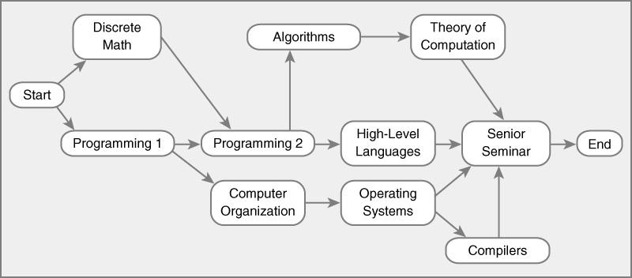

Start, discrete math, programing 1, programming 2, Computer organization algorithms high-level languages, Operating systems, Theory of computation, Compiler senior seminar, end.